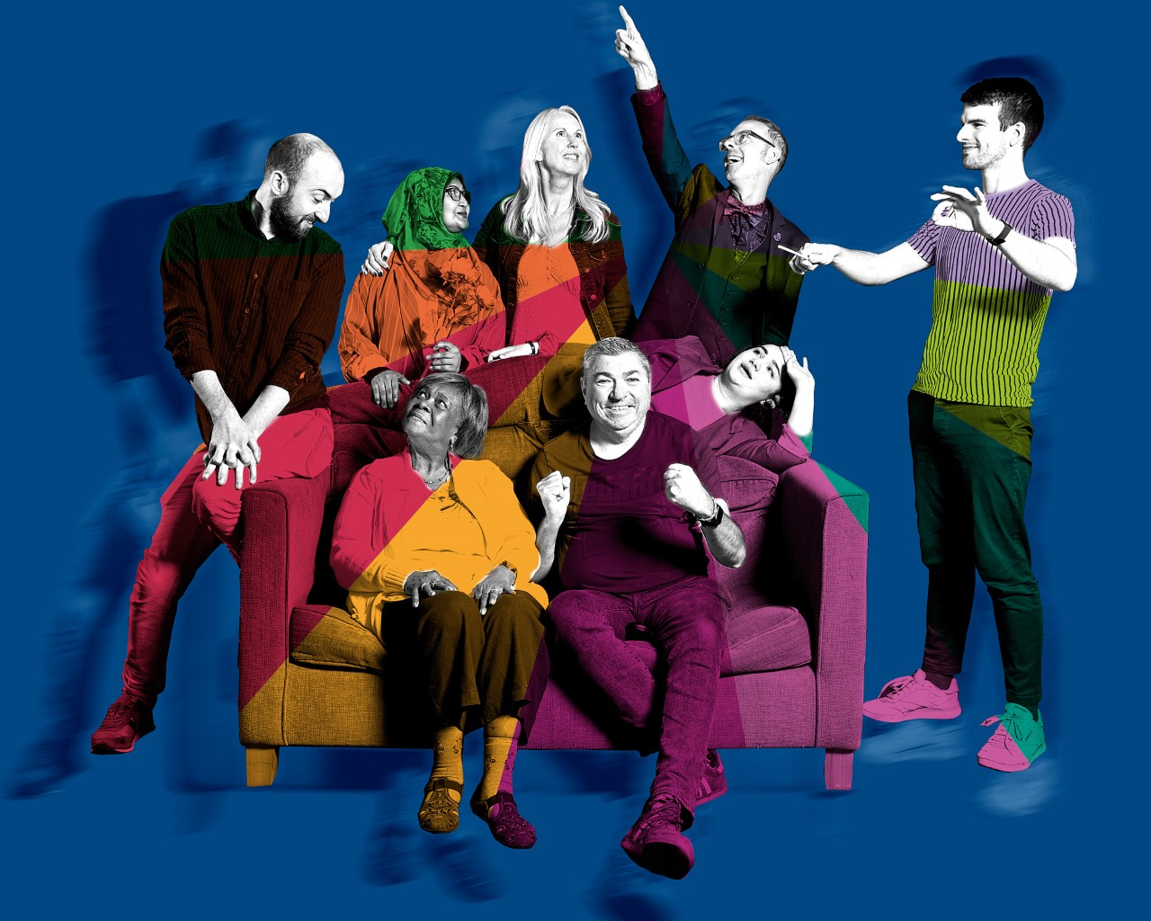

SYMPHONY OF US
An epic and personal spectacle made by six people of Cov, a local creative team and Orchestra of the Swan.

Six people of Coventry share with you the stories of who they are, supported by an original live composition played by the region’s most established chamber orchestra.

These proud Coventrians, either born in the city or who have made it their home, are teachers, are parents, are quietly changing the world. They are midwives, they are football fans, they are spiritualist ministers. They have experienced loss, they have experienced joy. They are a little part of ‘us’, a little segment of the people who contribute to this world but rarely get a live orchestra to sing their praises.

Join Orchestra of the Swan, Nor Aziz, Moz Baker, Duncan Brightside, Sam Collinge, Lynette Coulston, Daniel Fardon, Roze Navab and Paul O’Donnell for this epic and personal classical experience at Coventry Cathedral.

This is a unique theatrical symphony. It is a Symphony of Us.

CREDITING
An original idea by Paul O’Donnell
Created in collaboration with Nor Aziz, Moz Baker, Duncan Brightside, Lynette Coulston, Sam Collinge, Daniel Fardon, Roze Navab, Tessa Walker.

Writer: Paul O’Donnell
Original composition and conductor: Daniel Fardon
Director and dramaturg: Tessa Walker

Producer - Paul O’Donnell
Producer Support - Sarah Jane Watkinson
Access Producer - Lisa Franklin
Production Manager - Thomas Langford
Sound Designer - Drew Coleman
Lighting Designer - Arnim Friess

THE CREATIVE TEAM

Paul O’Donnell
[Theatre-maker / Performer / Producer]
Paul O’Donnell is a solo theatre maker, performer and producer based in Coventry who aims to expose the ‘ordinary’ in a ‘spectacular’ fashion.

He has earned two Audience Awards at international festivals and toured extensively across the UK, Spain, Canada and America. He has also built a local audience for his work in Coventry, with his hit show We’ve Got Each Other selling out at Warwick Arts Centre in a matter of hours of going on sale. He is excited to be given this ambitious opportunity to create work in and for the city he calls home.
Website: www.podonnell2.co.uk

Tessa Walker
[Director / Dramaturg]
As Associate Director at Birmingham Repertory Theatre Tessa directed Jekyll and Hyde by Evan Placey, 101 Dalmatians by Debbie Isitt, The Whip Hand by Douglas Maxwell, Looking for John by Tony Timberlake, Folk by Tom Wells, The Quiet House by Gareth Farr, The Lion, the Witch and the Wardrobe adapt, by Adrian Noble, A Christmas Carol adapt. by Bryony Lavery, The Mother adapted by Mark Ravenhill, Circles by Rachel De-Lahay, Back Down by Steven Camden and 366 Days of Kindness and How to be a Hero by White Rabbit Theatre.

She has also been a Literary Director at Paines Plough and a Literary Associate at the National Theatre of Scotland.
Website: www.unitedagents.co.uk/tessa-walker

Daniel Fardon
[Composer]
Daniel is a composer and performer who was born and grew up in Coventry. Daniel's work has received various awards including an Ivor Novello Award in 2020 for his Six Movements for string quartet, which premiered at the Wigmore Hall. In 2018, Daniel won the prestigious Royal Philharmonic Society Composition Prize. His music has been broadcast on BBC Radio 3, and commissioned and/or performed by internationally acclaimed ensembles including The London Symphony Orchestra, members of the City of Birmingham Symphony Orchestra, The Birmingham Contemporary Music Group, The Schubert Ensemble, The Britten Sinfonia, and the Carducci Quartet.

Daniel is currently a teacher at the Purcell School for Young Musicians, and also works as a community musician and workshop leader across the UK, particularly in the West Midlands.
Website: www.danielfardon.com

Orchestra of the Swan
[Orchestra / Orchestra Management]
Formed in 1995, Orchestra of the Swan is a British chamber orchestra which, under the artistic direction of David Le Page, is passionate about audience inclusivity and blurring the lines between genres, through its adventurous and accessible programming. The Swan is proof that an orchestra really can be an indispensable and relevant part of the community with its aim to entertain, educate and engage in a way that truly makes it a living orchestra.
Website: www.orchestraoftheswan.org

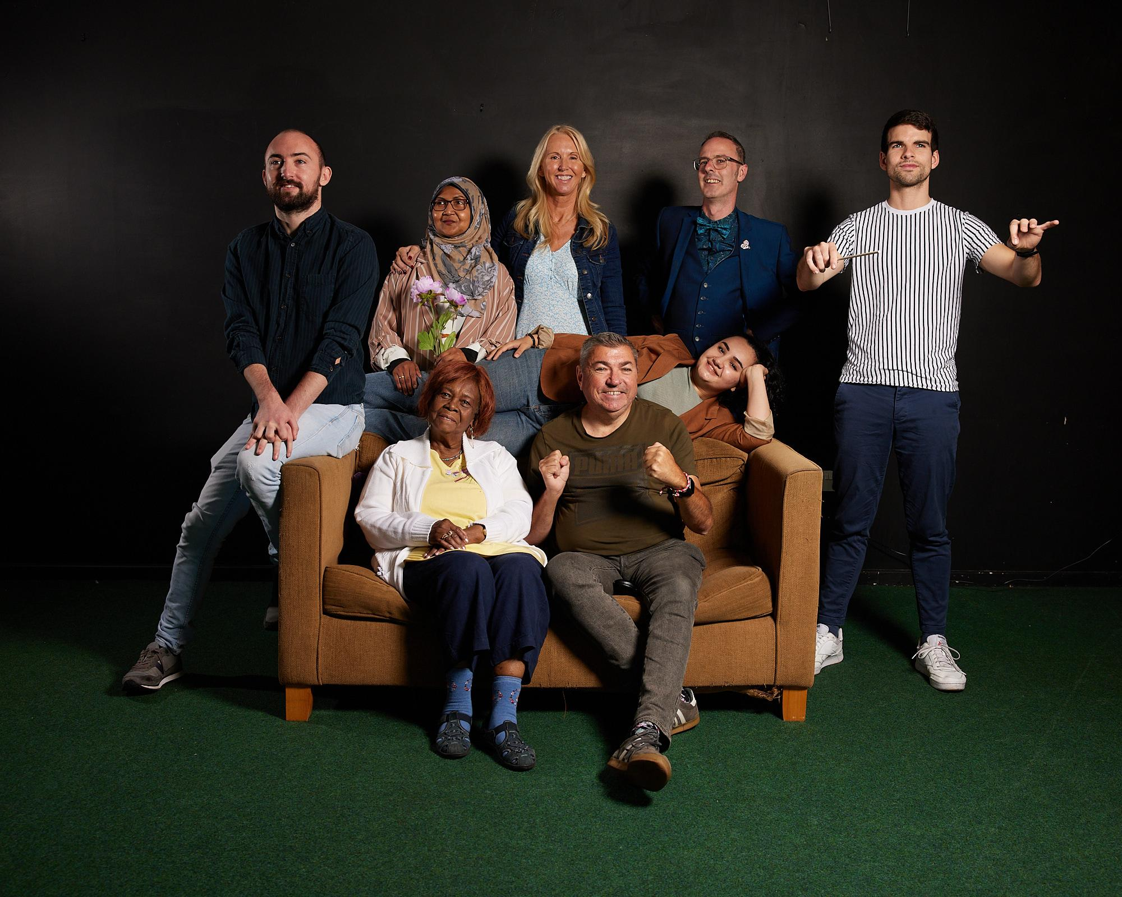

THE PARTICIPANTS

Nor Aziz
A keen gardener who looks at the world through looking at her garden. Born in Malaysia, a mother of 6, three of whom were born in Coventry. Nor organises Canley Big Lunches as opportunities for her region of Coventry to share a lunch together in the park.

Moz Baker
Coventry City Football Club fan and ‘Cov kid’ born and bred. Accidentally became Chair of the Sky Blue Trust through the campaign to bring CCFC back home to Cov from Northampton. Through it all he ‘just wanted to be a fan’. Father to two children.

Duncan Brightside
A primary school teacher and passionate LGBTQ+ advocate. Duncan has also accidentally become a Chair of Prism LGBTQ+ which is a network offering support to children or young adults coming to terms with their sexuality. He hopes to offer the support that he didn’t have as a child.

Sam Collinge
A mother of two and wife to a husband who she found irritating at first but now loves dearly. Sam is an NHS bereavement midwife, having worked in the position for nearly 30 years. When she started she was the first person in her role in the area and so had to devise the process of support from scratch.

Lynette Coulston
An 87 year old Spiritualist Minister who was born in Guyana, but can talk for England. She has lived in Coventry more than half of her life. Lynette has given birth to 9 children. She is retired as a secondary school teacher and is now passionate about supporting families who have lost children due to PTSD.

Roze Navab
Roze is a 21 year old who was born in Iran, came to Coventry aged 2, and has lived as a ‘Cov kid’ ever since. After seeing a tapestry in Coventry Town Hall she was inspired by our Twin City history to set up Twin Studios. She works to build creative connections with our twin cities across the world and hopes to forge three more twin cities.

Potential Press Angles
- Coventry / Coventry City of Culture
- West Midlands
- Attitude mag/ Cov LGBTQ community / The Yard – Duncan
- CCFC connections Moz – match day programme / screens at Ricoh / Sky Blue Supporters trust / Sky Blue bar
- Lynette – faith community
- Nor – Muslim community
- Sam – Nursing Times
- ​​Cathedral Audiences
- Orchestra of the Swan Audiences / Press
- Bereavement
- Nursing Times
- Sam - internal mailout of NHS staff?
- Roze - Twin Studios connections
- Teaching connection - Lynette and Duncan

